**VERTICAL AXIS WIND TURBINE (VAWT) TECHNICAL FEASIBILITY STUDY REPORT.**

**Wind behavior in different topographical settings.**

**Wind Speed Observations in the coast**

This case study is based on wind speed observation on the North Sea Coast. Statistical analysis of 8-year datasets shows the mean wind speeds are 7.5m/s at 18.5m and 7.6m/s at 15m. Effects of thermal circulation can be felt well up to 30km offshore which lowers the wind speeds to below 7m/s. Wind speeds in Kenya’s coast average at 7.2m/s.

**Wind Speed Characteristics in Cities**

The shape in buildings can cause localized wind acceleration or turbulence in severe cases. Individually, buildings can cause the down-draught effect, which makes the surrounding streets and sidewalks windier. In groups, buildings can form “Street Canyons” which are roads that have many tall buildings on each side.

The down-draught effect: How high rise buildings affect the wind.

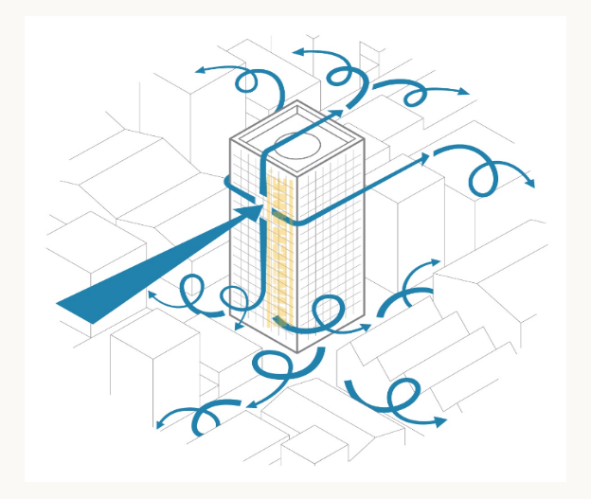

When wind reaches the wall of a building, it gets deflected in all directions. Some of the wind is deflected upwards and around the sides of the building, causing no effect at ground level. However, a significant portion of the air is deflected downwards along the building wall, causing draughtness and turbulence at ground level.

If wind is parallel to the direction of the street canyon, it **accelerates** as it is confined to a reduced space. If wind is perpendicular, it creates a large pocket of **turbulence** in the air volume contained between the two groups of buildings. Combination of both effects may occur when wind hits the street canyon at an angle: accelerates along the canyon direction, along with turbulence.

The way in which these effects present themselves is influential by the dimensioning of the street canyon: the buildings to the sides determine its height, the street determines its width and both features determine the canyon length.

Mean monthly wind speed in Nairobi is approximately 4.5m/s.

**Wind Speeds in Highly Elevated Areas**

Generally, the average wind velocity ranges between 10m/s to 20m/s for altitudes between 3000m and 8000m.

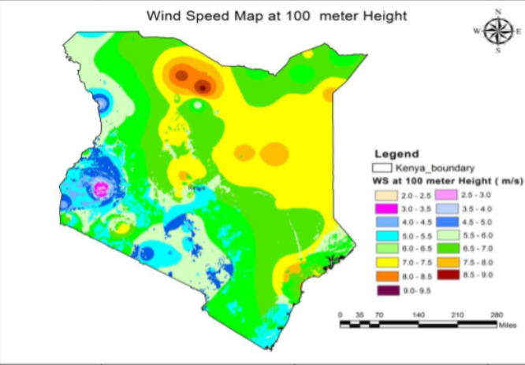

*Fig1. Wind Speed distribution in Kenya at 100m*

**Vertical Axis Wind Turbine Proposed Concept**

The wind turbine is of **H-Darrieus** type having **three blades**. The rough dimensions are: **500mm – 1000mm** blade length and **250mm-500mm** radius. The blade sections will constitute optimized airfoil sections and will be arranged as ribs to ensure the correct longitudinal shape is achieved. See fig2.

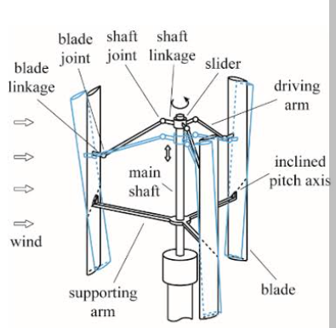

*Fig2. VAWT components*

**Blade Design & Fabrication**

There are two feasible methods for accurate fabrication of the blades:

1. 3-D printing.

The airfoil sections are 3-D printed and joined together in determined spaces intervals to form the blades of the wind turbine.

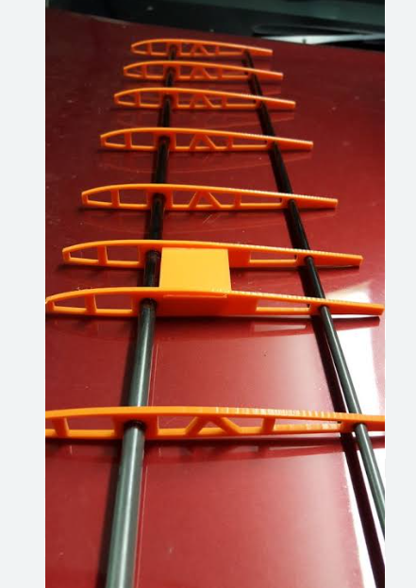

1. Laser-cutting

Laser cutting involves cutting of a material by a laser beam. The cut material precisely matches the designed shape.

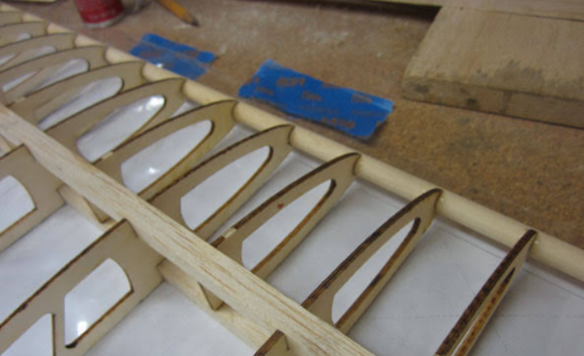

**Blade Materials**

**3-D Printing**

The materials commonly used in 3-D printing are:

1. ABS
2. PLA
3. Polyamide-nylon
4. PETG

Optimized Properties

1. PLA

Easy to print and is biodegradable. Does not have the highest of mechanical properties. Tough PLA has increased impact resistance and has no brittle failure as normal PLA.

1. ABS

ABS offers better mechanical strength and heat resistance compared to PLA. It’s suitable for applications where durability and higher-temperature resistance is required. It is not as flexible as the other materials hence does not qualify as a candidate considering wind-induced vibration.

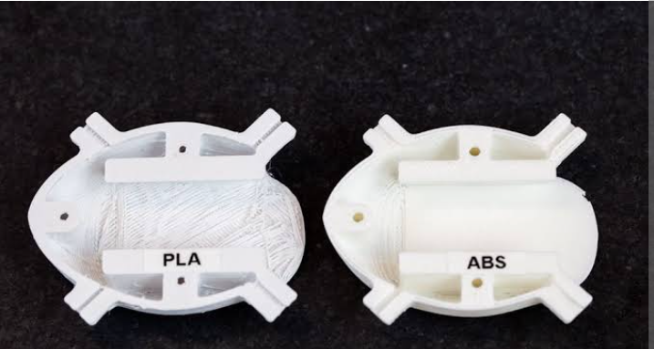

1. Polyamide-nylon

Known for its excellent mechanical properties, including high strength, flexibility, and durability. It’s a good choice for parts subjected to stress, wear, or high-impact loads. Its flexibility can also help withstand wind-induced vibrations.

1. PETG

PETG combines the ease of printing of PLA with better mechanical properties, such as improved impact resistance. PETG offers a good balance of strength and flexibility. It is resistant to UV exposure which is important for outdoor applications.

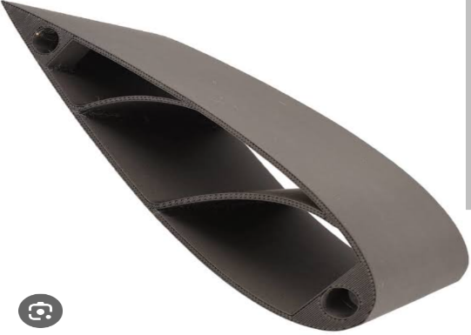

**PETG** stands as the optimized material for 3-D printing based on evaluation of the properties above.

**Laser Cutting**

Use of the laser cutting technology is appropriate in materials below:

1. MDF
2. Plywood
3. Veneer
4. MDF

MDF is medium-density fiberboard which is an engineered wood product made by breaking down hardwood or softwood residuals into wood fibers, often in a defibrator, combining it with wax and resin binder, and forming it into panels by applying high temperature and pressure. MDF is generally denser than plywood.

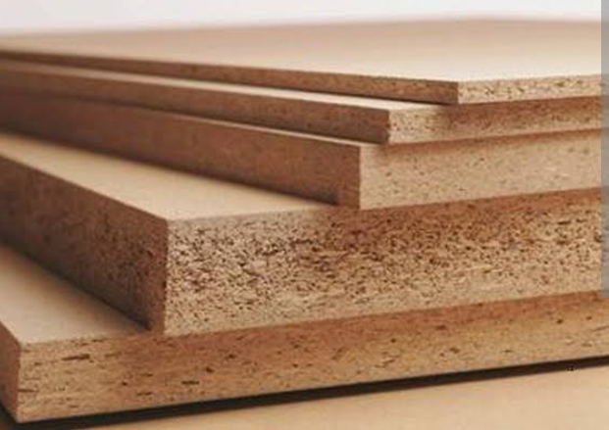

1. Plywood

Plywood is a composite material manufactured from thin layers or “piles” of wood veneer that are glued together with adjacent layers, having their wood grain rotated up to 90 degrees to another.  
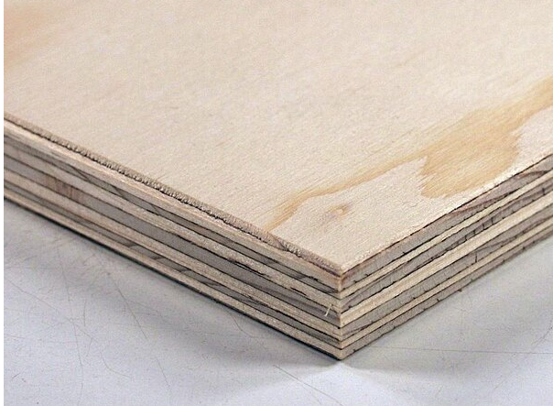

1. Veneer

These are thin slices of wood and sometimes bark that are typically glued onto core panels to produce flat panels such as doors.

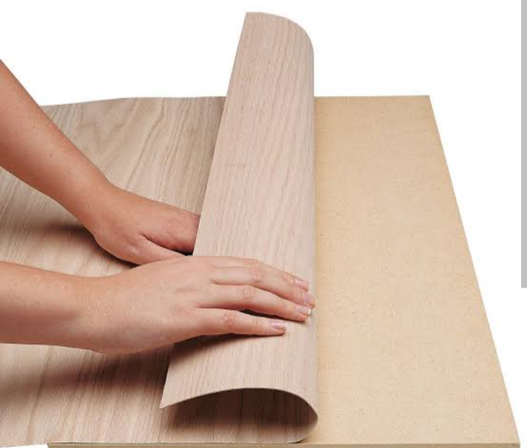

**Plywood** is the best material given its low density.

The airfoil sections will be joined together by a **wooded shaft/rod.**

The proposed materials for reinforcing the ribs longitudinally are **thin strips of wood**, thin **metal** **sheets** or small **metal rods**.

For the cover, the following materials are proposed.

1. Fiberglass

It is light weight, durable and can be molded to various shapes. It is also relatively resistant to UV exposure and weathering.

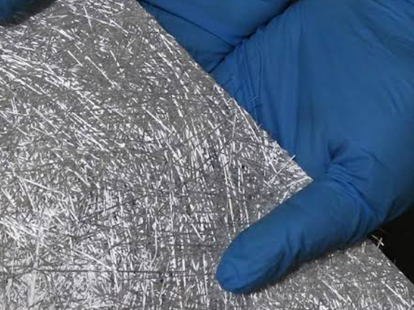

1. Carbon Fiber

Carbon fiber composites are known for their exceptional strengths and lightweight properties. They offer excellent rigidity and are often used in high-performance applications.

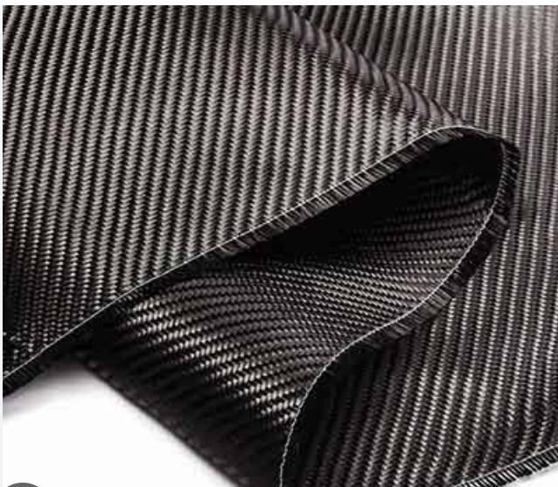

1. Plastics(PETG,ABS,Polycarbonate)

These materials are easy to 3-D print and mold. They offer decent durability and are mostly suitable for small projects.

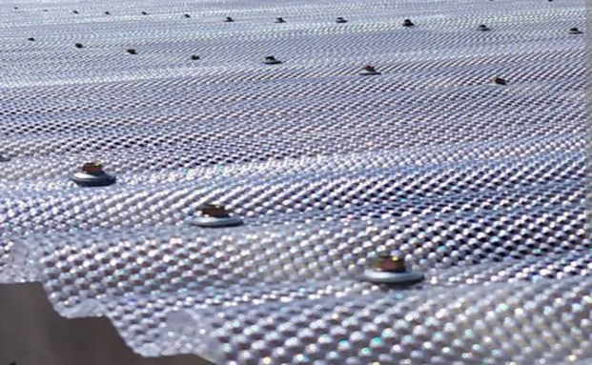

*Polycarbonate*

1. Aluminum or Metal sheets

Metal covers offer excellent durability and protection but may require additional manufacturing processes like cutting and shaping

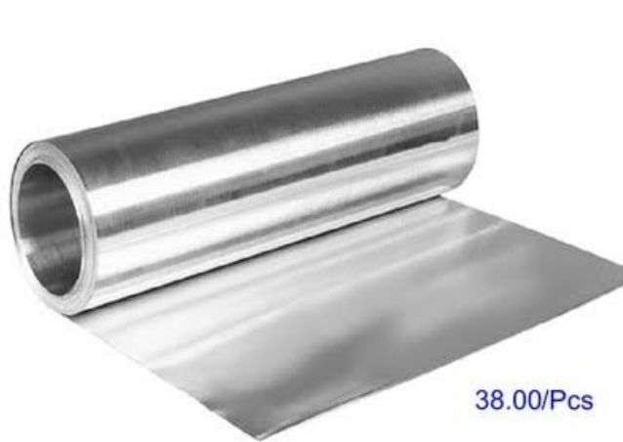

*Aluminum sheet*

**Metal sheets** stand out as good covers since it is easy to trace the shape of airfoil sections because of the thin sheets. These sheets provide a smooth profile on the blades hence minimizes parasitic drags on the blades.

**Design and Analysis**

The design phase of the VAWT will constitute application of theory from research in mechanical and electrical concepts. Optimized design will dictate the use of software for analysis, simulation and design.

**Hub:**

It is a part of the wind turbine that connects the blades to the main shaft .The hub is subject to high mechanical load, as it needs to transfer to the main shaft the torque produced from each blade.

The hub can be made in two ways:

Welded or casted however the casted one is structurally better there is no stress concentration generated by welding .However the welded one can be baked in the oven at high temp and slowly cooled to stress relieve

We can either use cast iron or aluminum if we are considering weight

-Design criteria for hub:

-Hub radius connection to shaft

-Possibility to adjust pitch angle

-Need for internal space to accommodate pitch control mechanism

-Accessibility of bolt heads

-Weight

-Cost and ease of manufacture and assembly

**COUPLING**

The turbine produces rotational energy and the generator converts that energy into electrical energy .The shaft coupler connects the turbine and generator shafts allowing the rotational energy to be transferred from the turbine to the generator. It also helps to align the two shafts ensuring a smooth and efficient transfer of power.

The VAWT wind energy converter is omnidirectional it accepts wind from all directions and does not need a yawing mechanism .VAWT has turbines with straight blades attached to the drive shaft via support arms. It is expected that the drive shaft will be long. We will opt for flange coupling in which we can use steel or aluminum.

**Gearless turbine**

The turbine is connected through a shaft directly to the rotor of the generator .Direct drives will eliminate losses,maintenance and costs associated with gearbox .It also reduces the torsional constraints on the drive shaft imposed by eigen frequency oscillation .Enabling the shaft to be slimmer meaning the supporting tower can also be reduced .The direct driven generator will deliver an output with varying voltage level and varying frequency.

A full converter is needed as an interface to the grid .The generator's rotors will have permanent magnets instead of electromagnets (no field coils have to be electrified ).Furthermore efficiency is improved as rotor losses are eliminated

**PMSG and full converter**

Permanent magnet synchronous generators are one of the best solutions for small scale wind generation .Wind power rotates rotor of wind turbine ,which rotates rotor of permanent magnet type synchronous generator .The field rotate with rotor and stationary coils cut the flux of Rotor magnet and emf is induced in stator coils .

In a full converter wind turbine ,a generator is fully decoupled from the grid by the converter and the entire wind turbine power flow through the converter .Full converters provide maximum flexibility to meet grid stability requirements. The converter tracks the frequency and phases of grid voltage to keep the output current and frequency of turbines in consistent with those of the grid.

Disadvantages

1. The generator is bulkier

2. The permanent magnets magnetization is constant and non-controllable.

Eigen frequency oscillation: And oscillation occurring in a dynamical system in the absence of an external action by perturbing it at the initial moment by an external action from the state of equilibrium.

**Generation capacity**

We employ a basic power generation formula, considering air density, swept rotor area, wind speed, and a typical power coefficient. This formula provided the basis for calculating the expected generation capacity.

The theoretical power output generated by a wind turbine can be calculated using the following formula:

P=1/2 x Swept area x density of air x Cp x V³

Where

P is the power generated (in watts or kilowatts)

V is the wind speed (in meters per second)

Cp is the power coefficient, representing the efficiency of the turbine (typically between 0.25 and 0.45 for VAWTs)

With a blade length of 1 meter, the diameter of the rotor would be 2 meters.

The Swept Area would therefore be

A=πr²

A=3.142m²

The typical wind speed of 4.5m/s in urban areas will be considered in the calculations and an average Cp of 0.3

Hence power generated by a 1m blade length turbine would be

P=1/2x3.142x1.225x0.3x4.5³

=52.61W

=0.05261kW

Annually power generated can be calculated by multiplying the power output by (24x365)= 8760hrs

=0 05261kWx8760hrs

=460.87kWh for 1 turbine.

**Power Transmission.**

The generated electricity will be initially harnessed by the turbine's generator and then fed into an inverter system.

This inverter will convert the variable AC output of the VAWT into a stable AC current suitable for grid connection.

The converted AC power will be integrated into the existing local grid infrastructure

The generated electricity from the wind turbine is typically at a relatively low voltage. To efficiently transmit it over longer distances and connect it to the grid, we would have use a step-up transformer.

The high-voltage electricity from the step-up transformer is then introduced into the grid at a connection point

Step-down transformers may be used to lower the voltage before it reaches application points for safer use.

References

1. Journal of Wind Engineering and Industrial Aerodynamics: J.P.Coeligh, A.A.M Holstag, A.J.M van Wijk. *Analysis of speed observations on the North Sea Coast*. Volume 73, Issue2, February 1998. Page 125-214.
2. Website: windcrane.com
3. Website: weather-and-climate.com